**ABSTRACT:**

India is an agro based country. The main livelihood of the majoritarian population here is through farming who dwells in villages and feed the whole country. Food is one of the basic necessities of a human being, which is fulfilled by the framers. However, they fail to get proper price of the food they sell in the market. Hence, they are deprived from getting profits for their food. FARMERS SHOP helps them in getting proper price for their food and even get profit for their efforts.

for the farmers in which they can get maximum pricing for their outcomes. To be sold to the wholesale venders. This idea is Farmer shop in which farmers can sell their food for the highest price for their food to be sold and can earn profit. Also, farmers can register themselves and have various other facilities such as feedback, contact to the wholesalers, price notifications etc.

**INTRODUCTION:**

The farmers who grow crops according to the season and fertility of the soil, after growing the crops they accumulate the crops, further process and pack them and contact the wholesale vendors regarding the availability of stock. The wholesale vendor first asks the price to the farmer who tells the price at which he/she can sell at. The wholesale vendor aiming for his own profits negotiates with the farmer regarding the price the poor framers sacrificing their profits generally accept the price quoted by the wholesale vendor. So, he/she sell their food at low prices due to some unfavourable conditions such as financial problems, unavailability of wholesale vendors or market etc.

Keeping in mind the various issues which a farmer faces such as poor financial conditions, indebtedness, etc. for these problems, the farmers expects to get profit or even the price quoted at par for some or other improvement. But then he/she has to agree upon the low price quoted by the wholesale vendors due to some situation such as absence of unreachability of to the market, unavailability of other wholesale vendors etc, with expectation of some improvement though the money earned he/she bears lots as well. This happens due to the negotiation and saving mentality of the buyer. The seller quotes the high price aiming at his high profit but the buyer negotiates at low price considering their savings and due to the poor conditions of the farmers they are obliged to accept the low price from the wholesale vendors with expectation of some income. Hence, the farmers are unable to make profits.

Despite of all the hard work and patience to grow the food, farmers play a major role in the agriculture life cycle but still they fail to get profit due to their poor conditions.

In this project multiple user login first is farmer and another one is Buyer Farmer Add their food and Buyer Buy this food directly from farmer using our application.

Farmer can see his sells reports and orders if former can get multiple orders then he can reject which they don’t want to accept.

After accepting order from farmer buyer will be notified that the former accept their order and they can move further process for delivery.

**PROBLEM STATEMENT:**

The farmers who grow crops according to the season and fertility of the soil, after growing the crops they accumulate the crops, further process and pack them and contact the wholesale vendors regarding the availability of stock. The wholesale vendor first asks the price to the farmer who tells the price at which he/she can sell at. The wholesale vendor aiming for his own profits negotiates with the farmer regarding the price the poor framers sacrificing their profits generally accept the price quoted by the wholesale vendor. So, he/she sell their food at low prices due to some unfavorable conditions such as financial problems, unavailability of wholesale vendors or market etc.

for the farmers in which they can get maximum pricing for their outcomes. To be sold to the wholesale venders. This idea is Farmer shop in which farmers can sell their food for the highest price for their food to be sold and can earn profit. Also, farmers can register themselves and have various other facilities such as feedback, contact to the wholesalers, price notifications etc.

**Scope of the proposed system:**

**Customers:**

* A convenient method to order the agro products such as food grains, vegetables online in wholesale or retail
* Direct trade between customers and farmers through a virtual intermediary
* Ensuring a reliable customer service for customer satisfaction
* Timely delivery of stock keeping in mind non-perishability of goods.
* An innovative platform for buying agro products online

**System:**

* Customer satisfaction would result in building goodwill and reputation in market to increase reliability
* Employing better ways for customer satisfaction and customer retention through quality services and efficient consumer grievance system through feedback.

**Farmers:**

* Farmers can sell their Food online to the customers directly such that they can sell at profits by the price quoted by them to the highest price in which the customers are ready to buy
* Farmers can sell their food in both wholesale and retail quantities to the customers

**Advantages:**

* Anyone can see foods/products of site without registering
* Store All users data and display self-owned data to user.
* Famer get proper price for their food
* Buyer can get best food.
* Access from anywhere and anytime
* Farmer or Buyer can contact to administrator for help.
* Customer can go through to this site without registering themselves

**Hardware Requirements:**

**PC:**

* Any PC (Windows) should work and is what we recommend at this time, primarily because there are more touch screens whose drivers work with PCs and more kiosk manufacturers who use them. A laptop can also do.
* It could be that for your application a Mac or Linux box will work fine, but our priority for now is the PC platform.
* Select a PC that will fit inside whatever enclosure you may envision using (also see Kiosk below). We have been using HP laptops.

**Monitor:**

* The monitor must have a native resolution of 1280 x 1024 (SXGA). AED is designed for this resolution only.
* "Native" means that at that resolution images fill the entire screen and look the sharpest and best that the monitor can display. Alternate, non-native resolutions either will be stretched slightly resulting in a blurred look, or have unused black strips on the sides or top of the display.
* We don't currently support other display resolutions, which include most all of the recent crop of inexpensive large screen HDTV-like monitors on the market. There are a number of reasons but one good one is that we want to allow for an interactive experience, and the large screens are generally for multiple people to view from a distance, not for touching. Also, the aspect ratio of these screens tends to be wide, not squeamish, so our content would not make effective use of the screen's real estate without redesigning the content (which we are looking into).

**Internet connection:**

* Good: T1, T3; wired cable; wired DSL; uncongested, strong wireless
* So-So: congested or weak wireless; satellite; ISDN
* Not Okay: dial-up connections, non-24-7 connections
* Much of the content in the AED can and will be cached by your web browser, however certain items (mainly the seismicity maps) change often and therefore cannot be cached. The seismicity maps are currently about 250-300Kb in size. For this reason, we have had poor results in our tests using modems or congested wireless networks, such as at conferences, hotels or exhibition halls.

**Software Requirements:**

**Operating System:**

* Windows XP Pro, 10 or any Home Edition
* Linux
* Mac
* Android

**Security:**

* This is a very important concern. There will be those who will try to gain access to the PC, perhaps by finding a way to crash the AED software and get to the Desktop.
* Here are three security measures that can be taken:
* **Anti-Virus –**

We have installed Norton Anti-Virus software and find it to be OK, though purchasing and keeping it licensed and up-to-date via their website is difficult and annoying. A free package that seems to work fine and may be adequate for many users is called Clam Win Free Antivirus for Windows.

* **PC lockdown software -**

Microsoft makes a free package that will convert a Windows account to have very few privileges and "locks down" the machine when that user is logged in. It is called Microsoft Shared Computer Toolkit. We have not used this because of the time and energy needed to install and maintain it, and a lack of information relating to the value and reliability of it. It is for libraries and Internet cafes. It looks promising but a tad complex

* **Browser:**

At this time, we are evaluating whether we want to endorse Internet Explorer or Firefox as our recommended browser. Most of our development and testing was done with Firefox and chrome, because until recently, these were the browser with the best full screen support.

* **Domain:**

The coding was done for www.agromart.com and the languages used in it for construction and working of website were html, CSS, JavaScript php, and for database MySQL was used. For project and related estimations and calculations, project liber was used.

**SOFTWARE INTERFACE**

**FRONTEND / DESIGNING LANGUAGE:**

1. **HTML :**
   * HTML stands for Hyper Text Markup Language
   * HTML is the standard markup language for creating Web pages
   * HTML describes the structure of a Web page
   * HTML elements tell the browser how to display the content
   * HTML elements label pieces of content such as "this is a heading", "this is a paragraph", "this is a link", etc.
2. **CSS:**
   * CSS stands for Cascading Style Sheets
   * CSS describes how HTML elements are to be displayed on screen, paper, or in other media
   * CSS saves a lot of work. It can control the layout of multiple web pages all at once
   * External stylesheets are stored in CSS files
3. **JavaScript:**
   * JavaScript, often abbreviated as JS, is a programming language that conforms to the ECMAScript specification. JavaScript is high-level, often just-in-time compiled, and multi-paradigm. It has curly-bracket syntax, dynamic typing, prototype-based object-orientation, and first-class functions.
4. **Bootstrap:**
   * Bootstrap is a free front-end framework for faster and easier web development
   * Bootstrap includes HTML and CSS based design templates for typography, forms, buttons, tables, navigation, modals, image carousels and many other, as well as optional JavaScript plugins
   * Bootstrap also gives you the ability to easily create responsive designs

**BACKEND / SERVER SIDE LANGUAGE:**

1. **Python:**
   * Python is a popular programming language. It was created by Guido van Rossum, and released in 1991.
   * It is used for: web development (server-side), software development, system scripting.
   * Python was designed for readability, and has some similarities to the English language with influence from mathematics.
   * Python relies on indentation, using whitespace, to define scope; such as the scope of loops, functions and classes. Other programming languages often use curly-brackets for this purpose.
2. **Django:**
   * Django is a high-level Python web framework that encourages rapid development and clean, pragmatic design. Built by experienced developers, it takes care of much of the hassle of web development, so you can focus on writing your app without needing to reinvent the wheel. It’s free and open source.

**DATABASE:**

1. **PostgreSQL:**
   * PostgreSQL is a powerful, open source object-relational database system with over 30 years of active development that has earned it a strong reputation for reliability, feature robustness, and performance.
   * PostgreSQL comes with many feature aimed to help developers build applications, administrators to protect data integrity and build fault-tolerant environments,
   * help you manage your data no matter how big or small the dataset. In addition to being free and open source PostgreSQL is highly extensible.
   * For example, you can define your own data types, build out custom functions, even write code from different programming Languages without recompiling your database!

**SOFTWARE USED:**

1. **VS Code (Visual Studio Code Editor)**
   * Visual Studio Code is a lightweight but powerful source code editor which runs on your desktop and is available for Windows, macOS and Linux. It comes with built-in support for JavaScript, TypeScript and Node.js and has a rich ecosystem of extensions for other languages (such as C++, C#, Java, Python, PHP, Go) and runtimes (such as .NET and Unity).
2. **SUBLIME TEXT EDITER:**
   * Sublime Text is a shareware cross-platform source code editor with a Python application programming interface (API). It natively supports many programming languages and markup languages, and functions can be added by users with plugins, typically community-built and maintained under free-software licenses.
3. **POSTGRESQL ADMIN:**
   * PostgreSQL, also known as Postgres, is a free and open-source relational database management system emphasizing extensibility and SQL compliance. It was originally named POSTGRES, referring to its origins as a successor to the Ingres database developed at the University of California, Berkeley.
4. **CHROME BROUSER:**
   * Google Chrome is a cross-platform web browser developed by Google. It was first released in 2008 for Microsoft Windows, and was later ported to Linux, macOS, iOS, and Android. The browser is also the main component of Chrome OS, where it serves as the platform for web apps

**ER DIAGRAM**

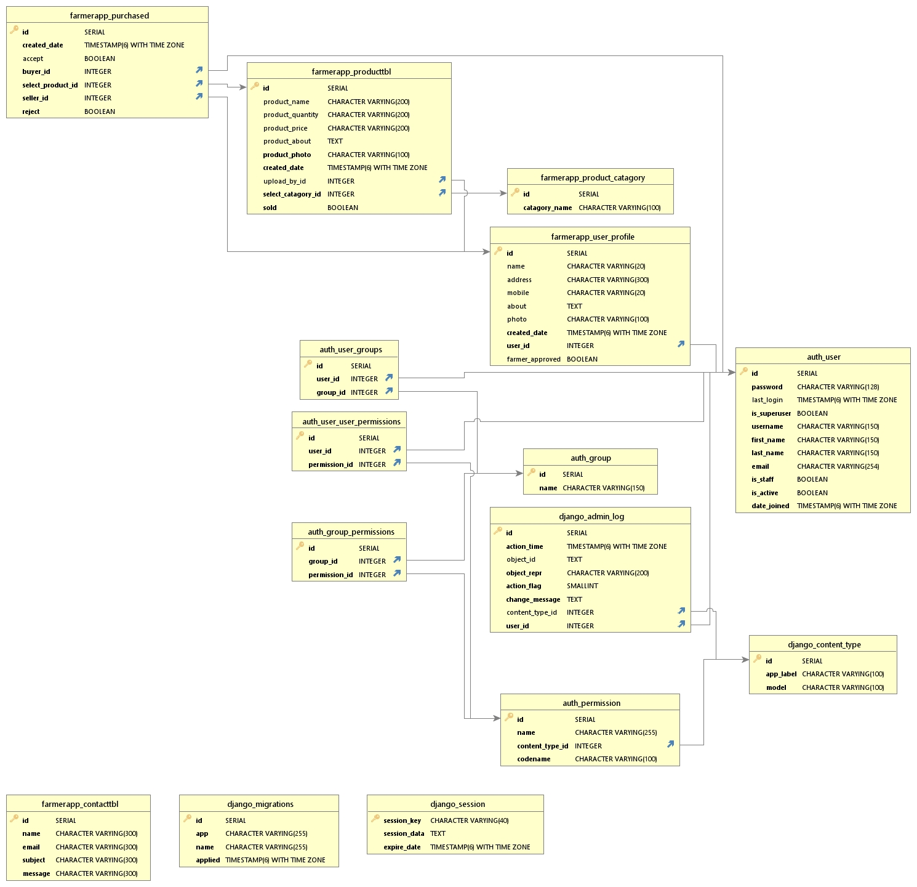

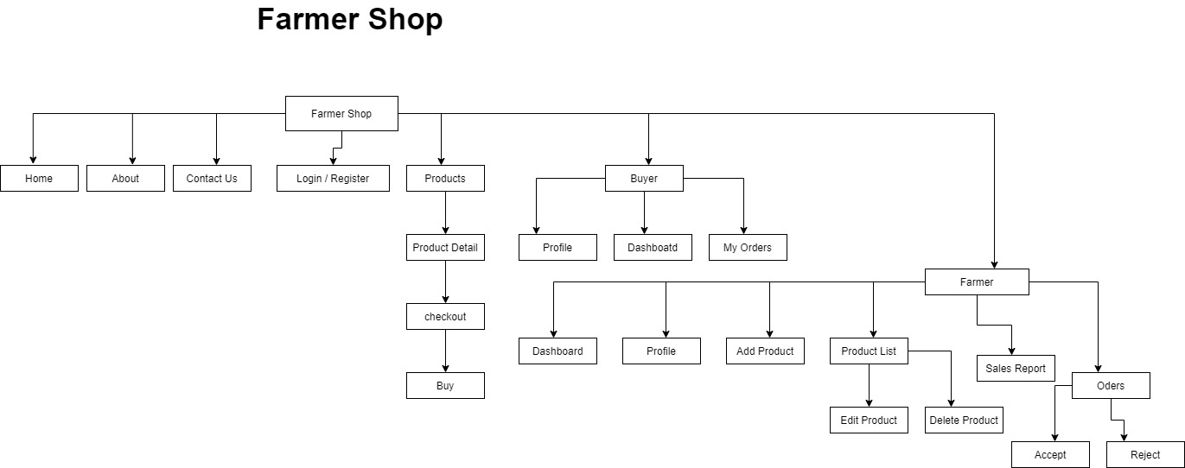**FLOW DIAGRAM**

**DATA FLOW DIAGRAM**

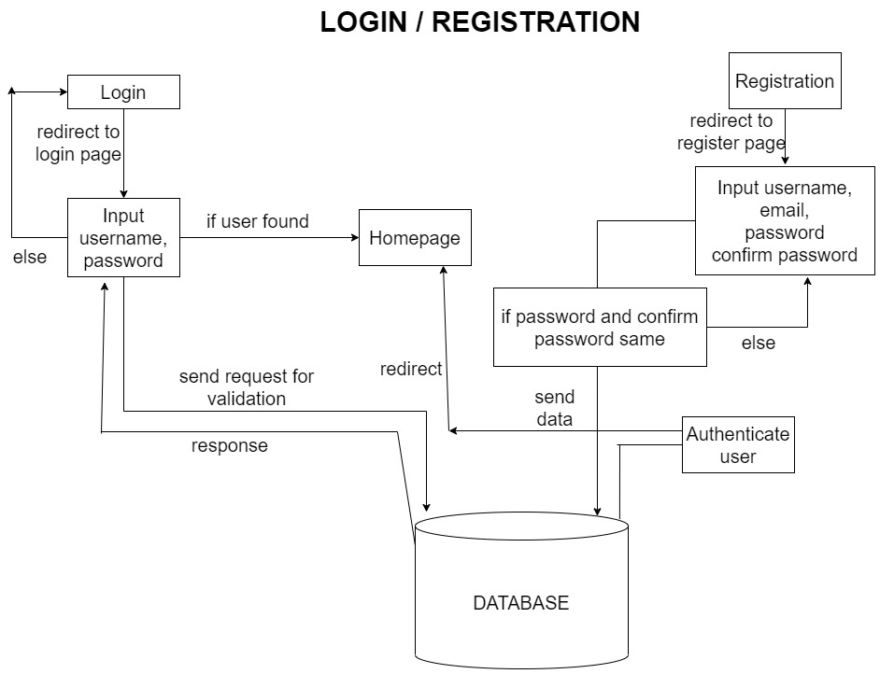

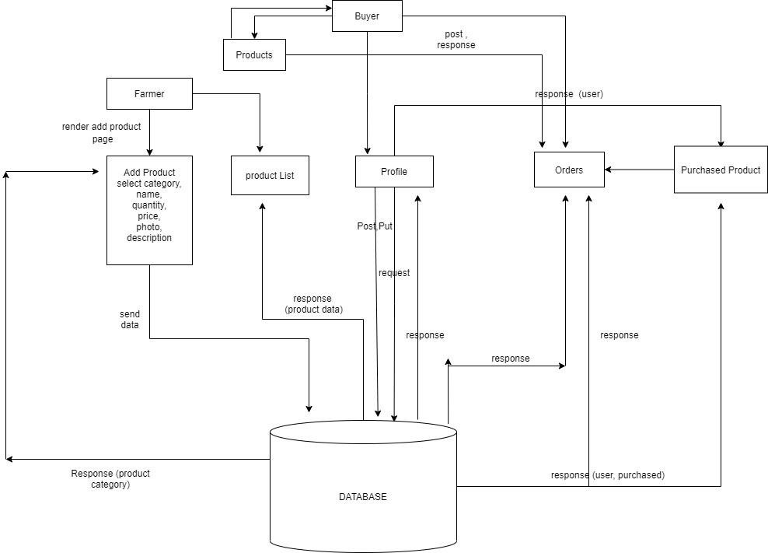

**MODULE**

Farmers Shop consist of Three Major Module, Which makes the Farmer Shop User Friendly and More efficient

These Modules are as follows:

* **Main Module:**

Main Module can be accessed without signing up, user can see food/ products from this site but cannot buy food without registration

* + Homepage
  + About Page
  + Contact Us Page
  + Products
  + Product Detail
  + Login for Farmer and Buyer
  + Register for Farmer and Buyer (farmer account need verification)
  + Search Functionality
  + Checkout Page
  + Login and Registration Page
* **Farmer Module :**
  + Farmer Dashboard
  + Profile
  + Add Product
  + Product List
  + Sales Report
  + Orders
* **Buyer Module:**
  + Buyer Dashboard
  + Profile
  + Orders
* **Admin Module:**

A database is that stores related information across multiple tables and allows you to query information in more than one table at the same time

In database you could set up multiple tables, one for Farmers and one for Buyers. The farmer table consist the all the information about Farmer like, Addedd Products, Personal Information and the Sales table consist all the related info orders and sales The database table include following tables:

* + Admin Dashboard
  + Users (create, read, update, delete)
  + Messages (create, read, update, delete)
  + Products (create, read, update, delete)
  + Product Category (create, read, update, delete)
  + Purchased Products (create, read, update, delete)
  + User Profile (create, read, update, delete)

**Registration Form:**

This is a simple Registration for Farmer or Buyer. This form contains Username, Email, Password, and Confirm Password fields and account type which is farmer or Buyer. We provide a password validation, Email validation and Username validation.

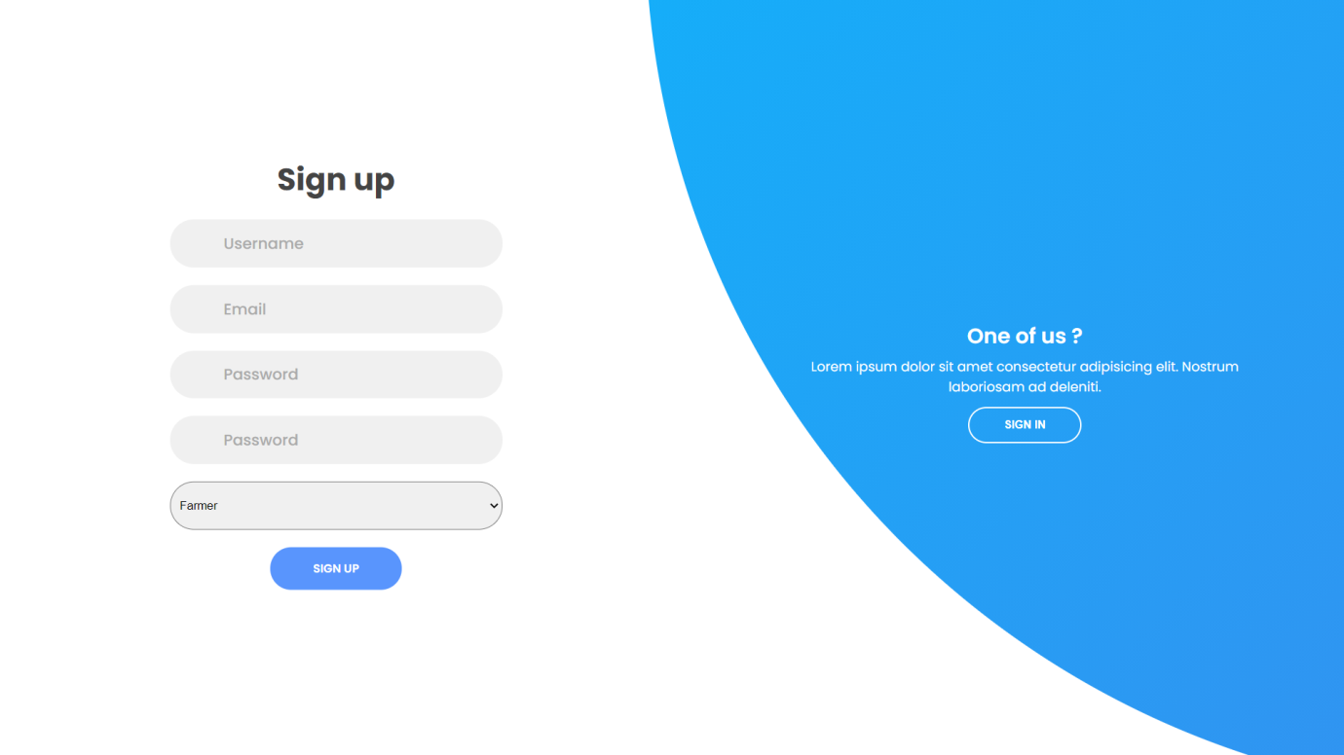

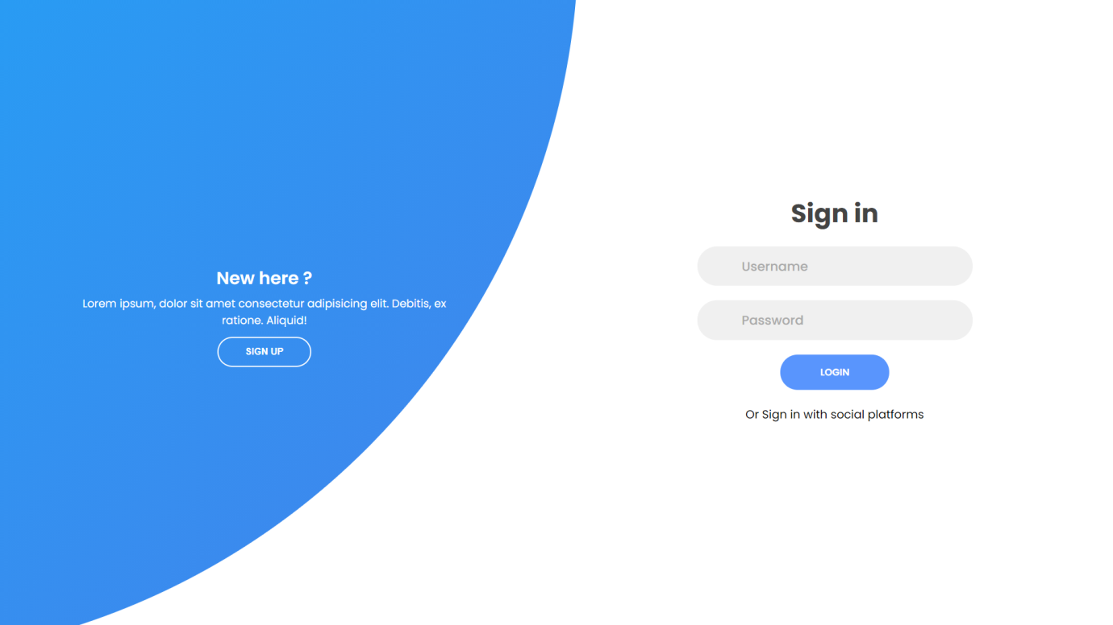**Login Form:**

**Home Page:**

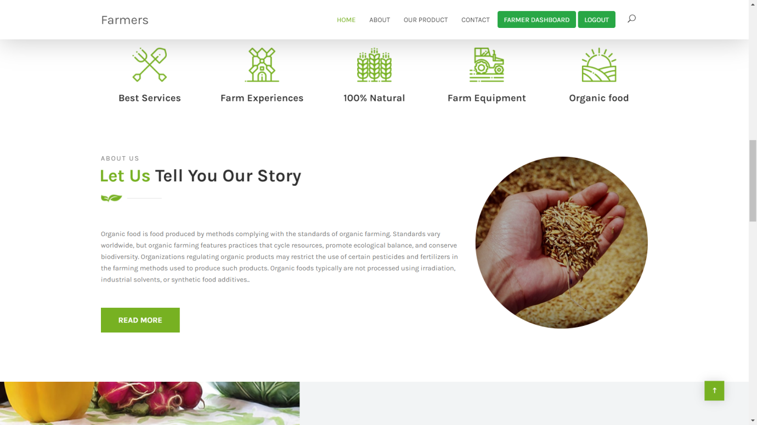

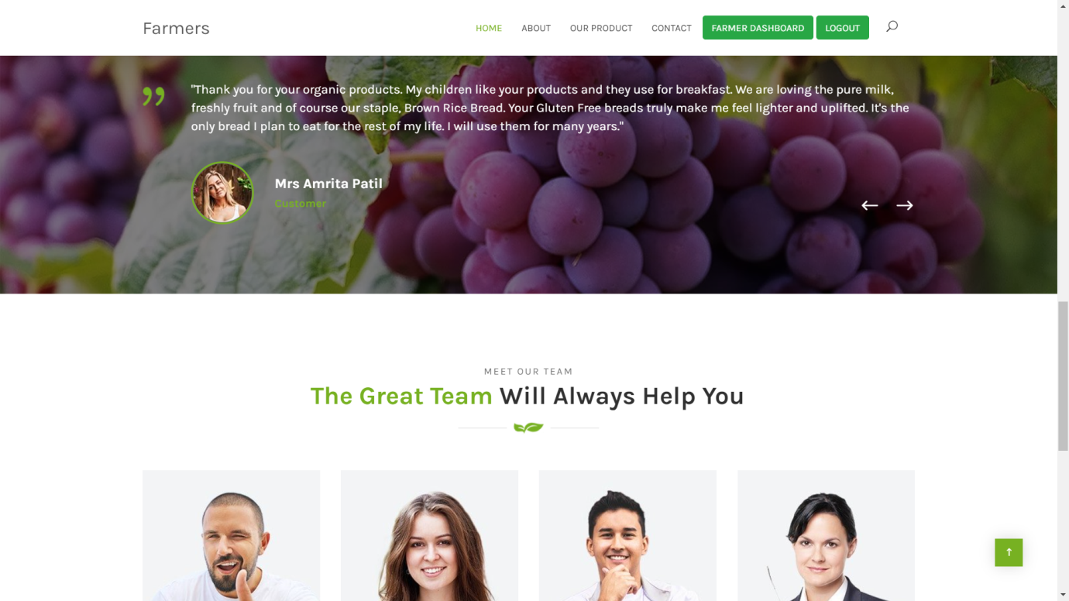

**Contact Us Page:**

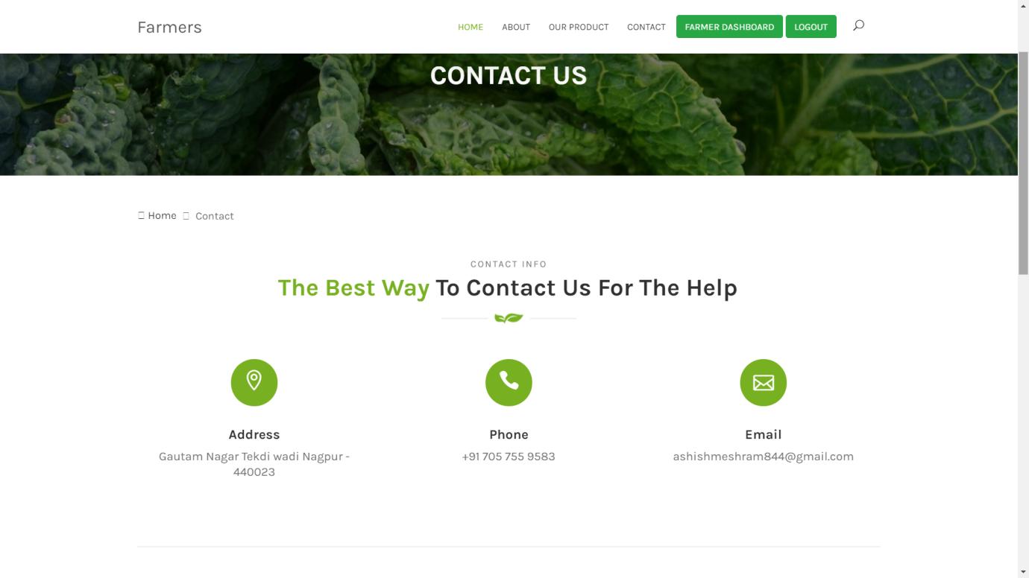

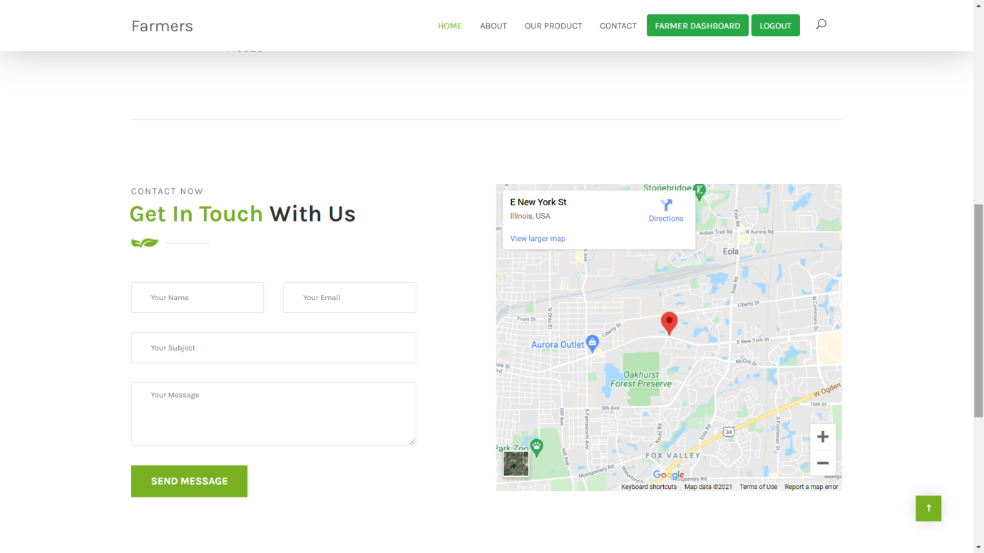

**Product Page:**

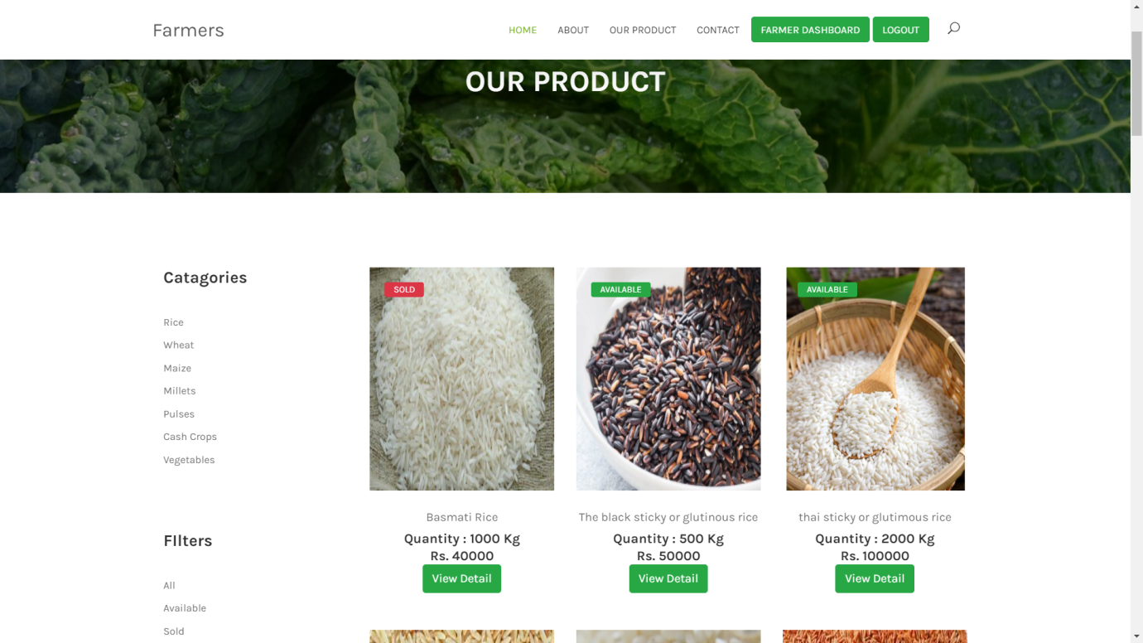

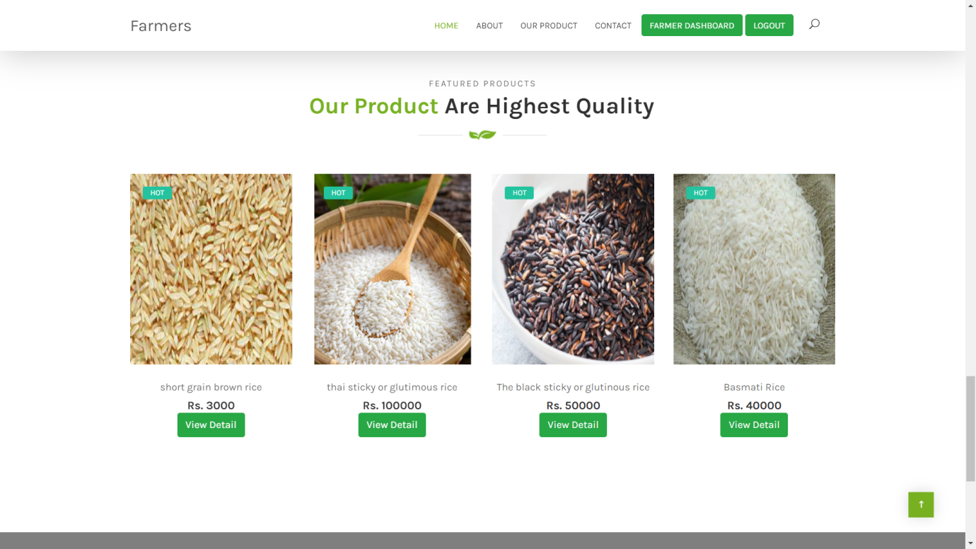

**Buyer Dashboard:**

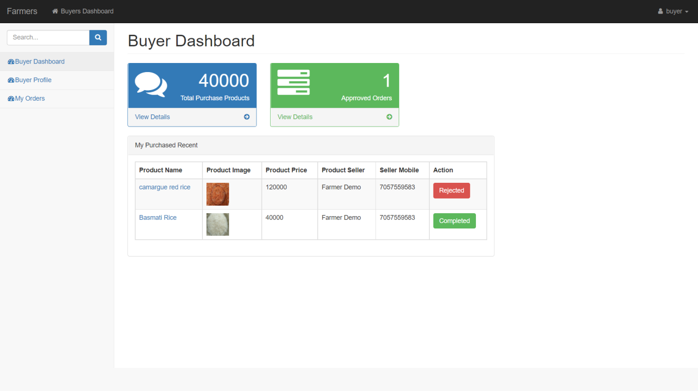

**Buyer Profile:**

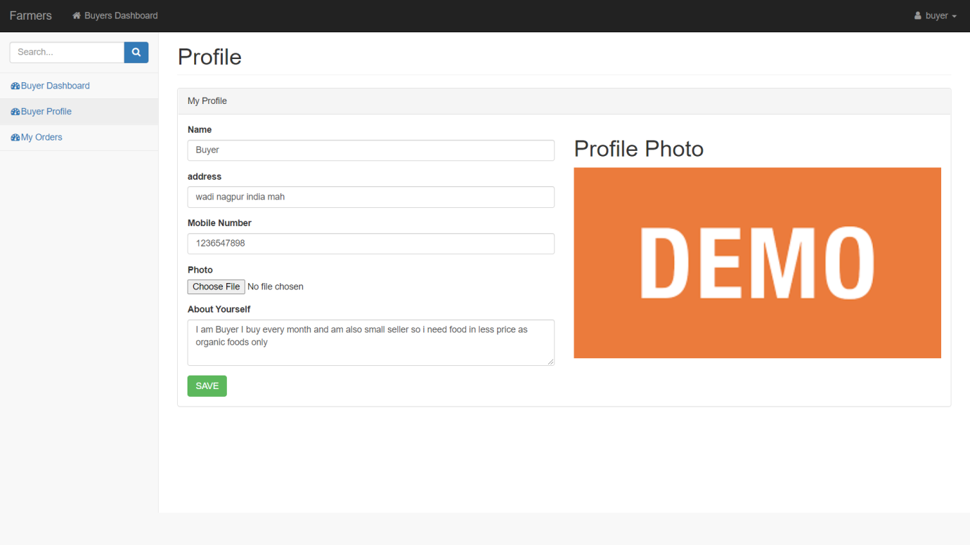

**Buyer Orders:**

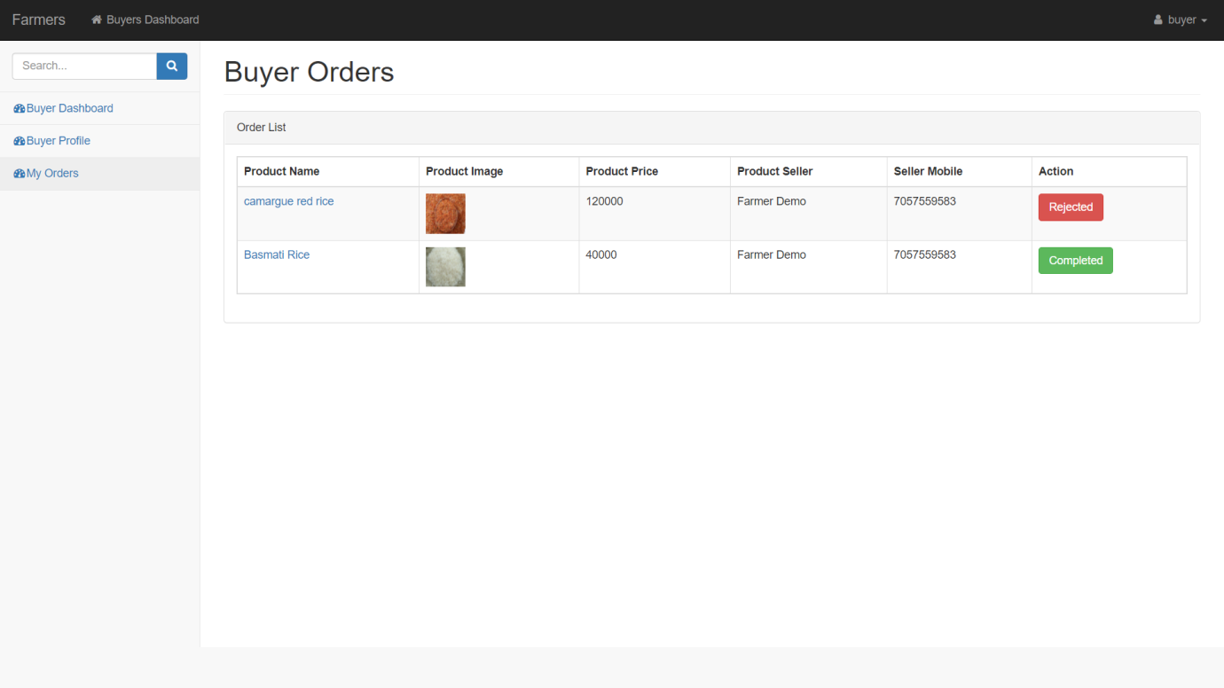

**Farmer Dashboard:**

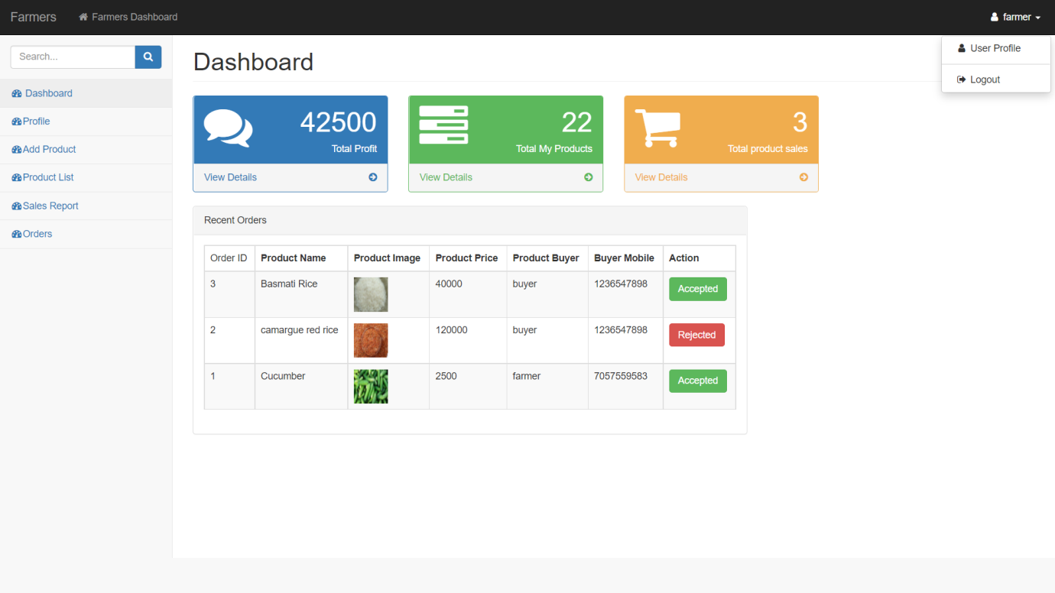

**Add Product Page:**

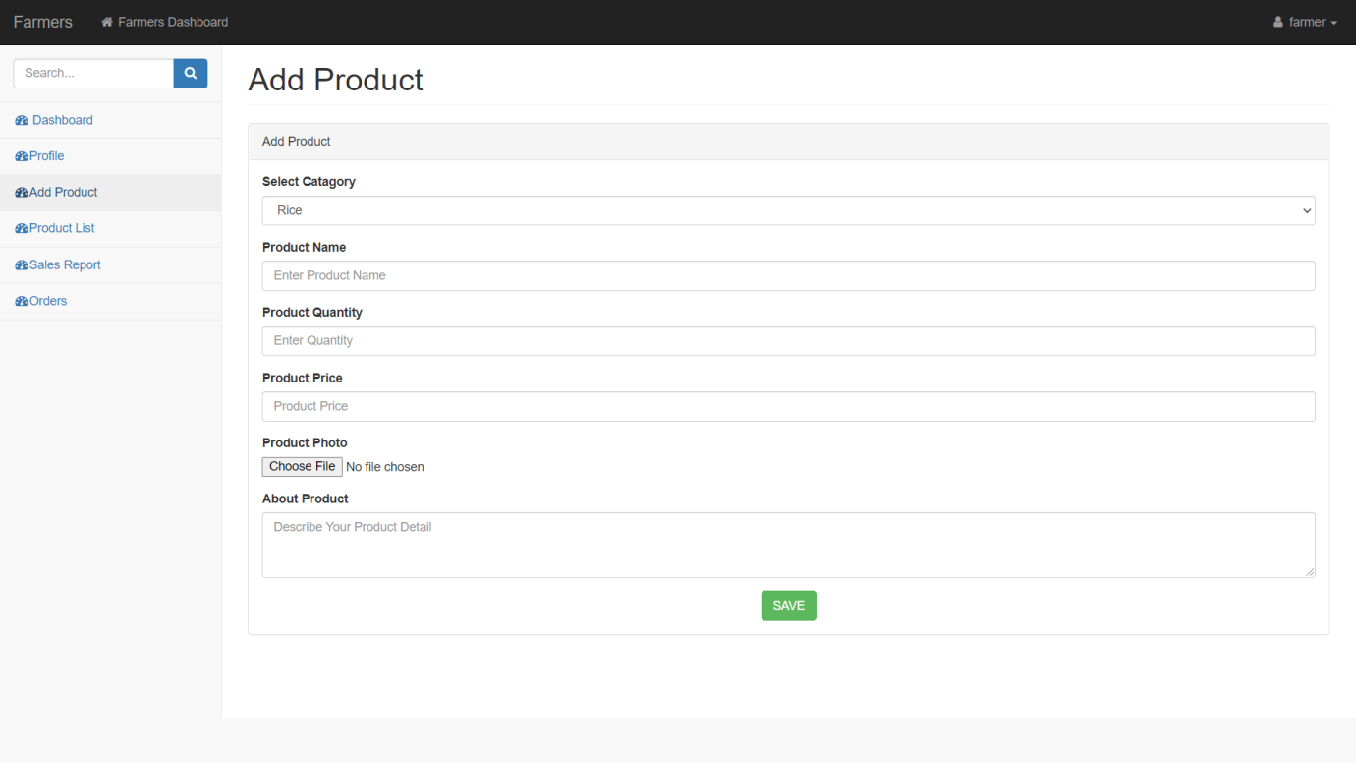

**Product List:**

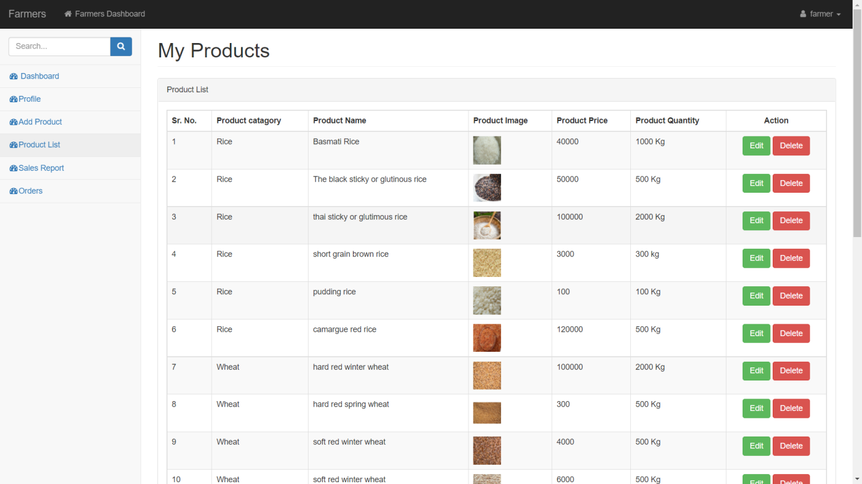

**Sales Record:**

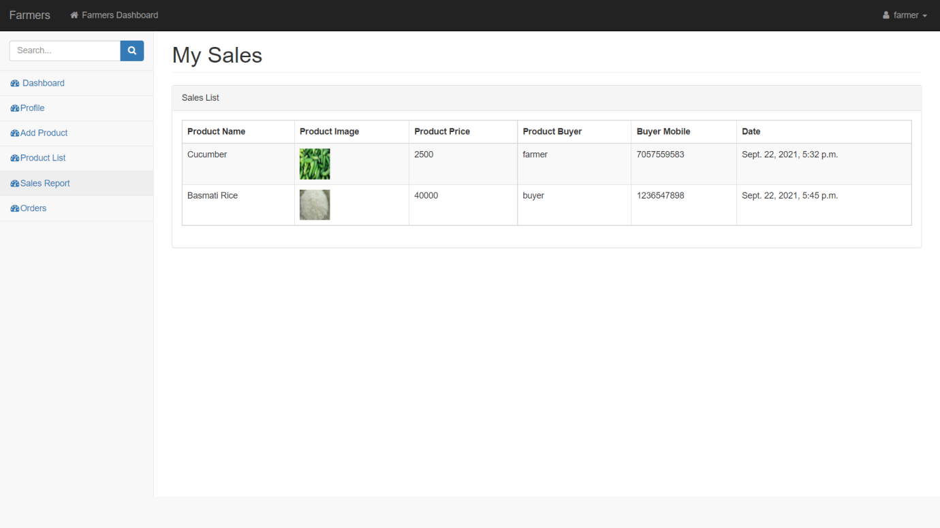

**Farmer Orders:**

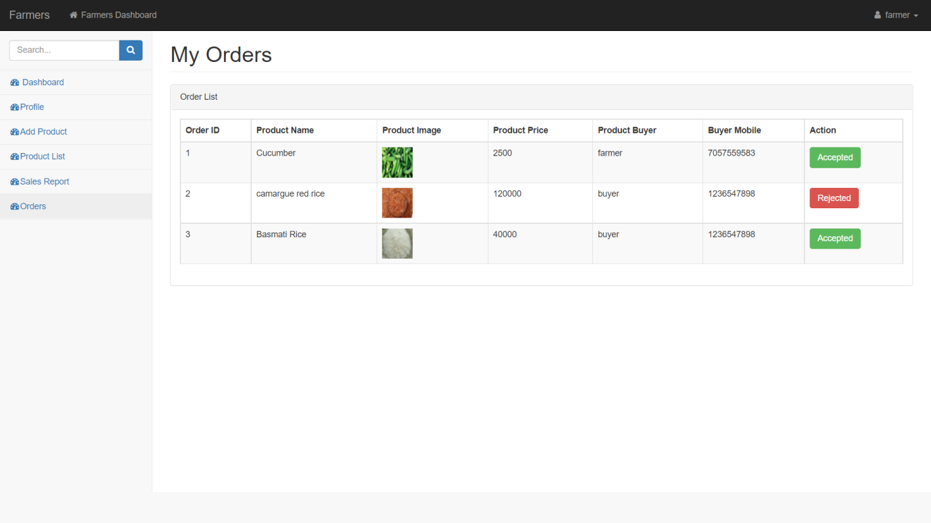

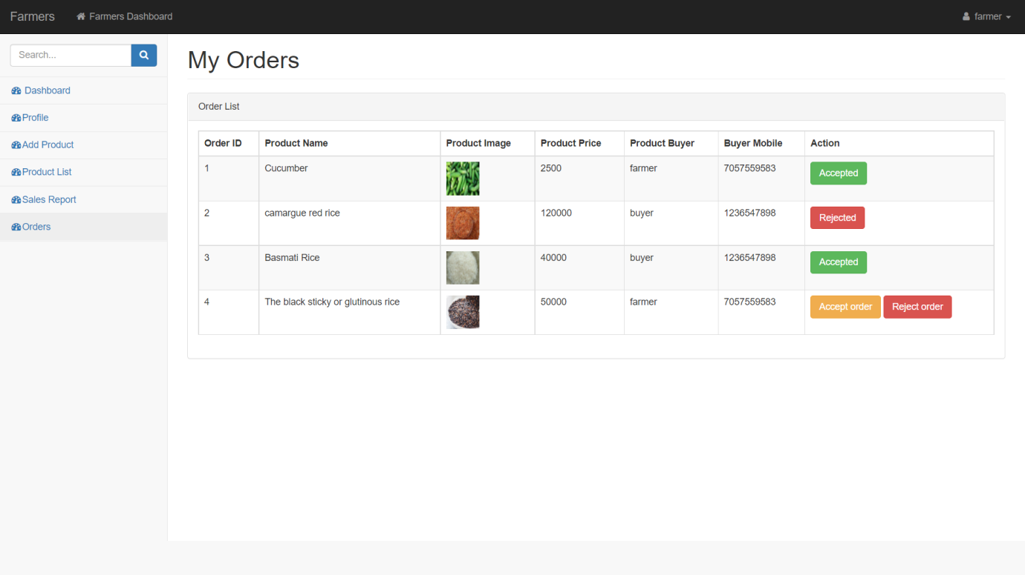

**Search Product Functionality:**

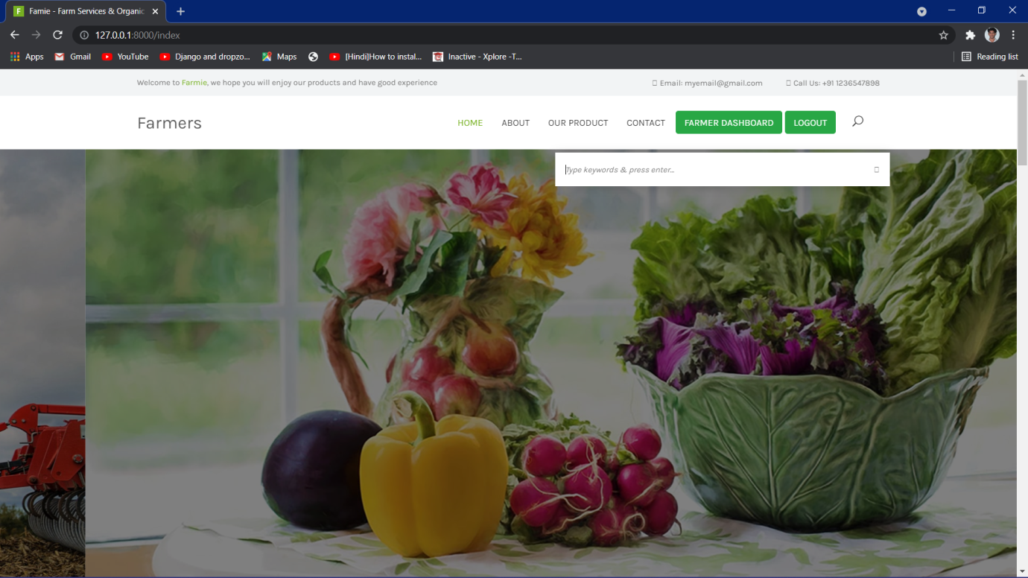

**Admin Dashboard:**

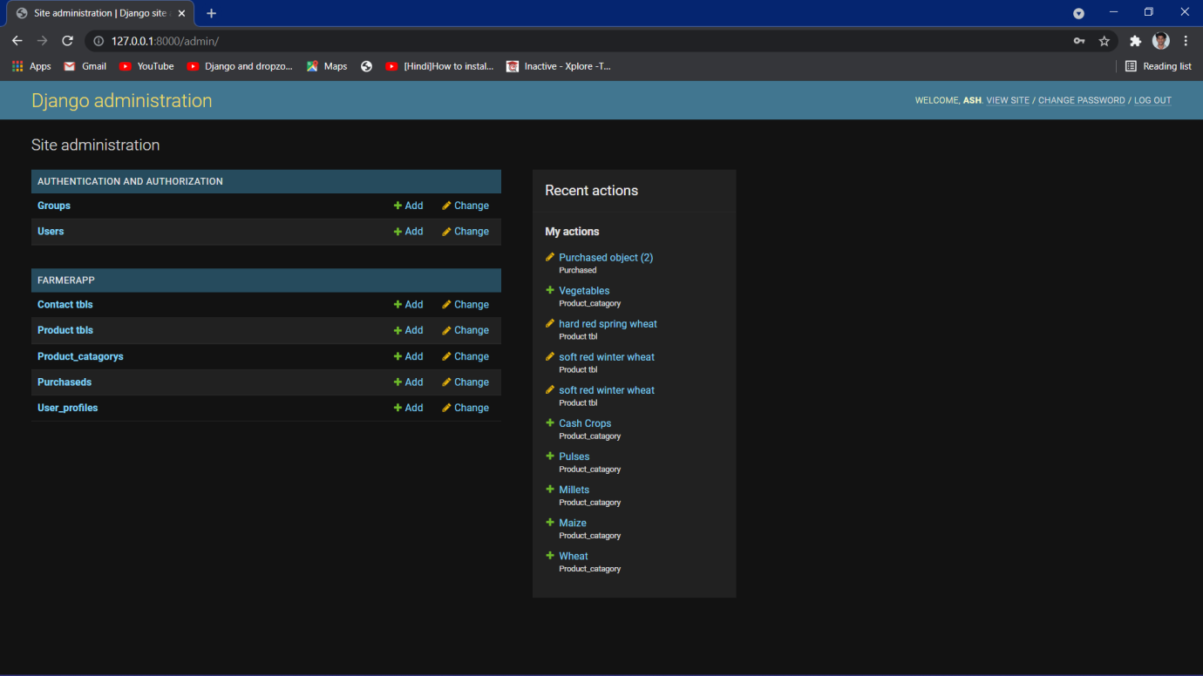

**Users List:**

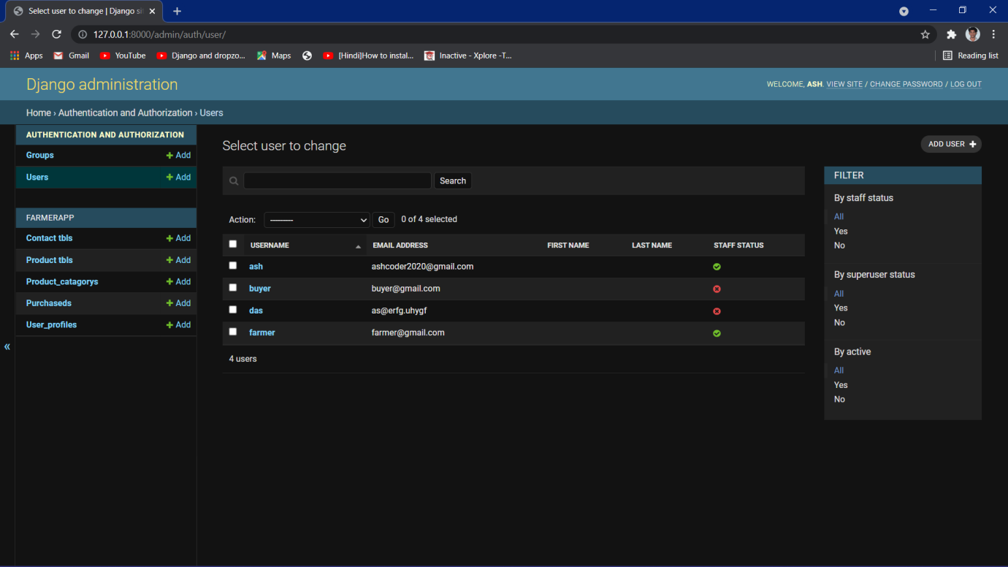

**Update User Info:**



**Product List:**

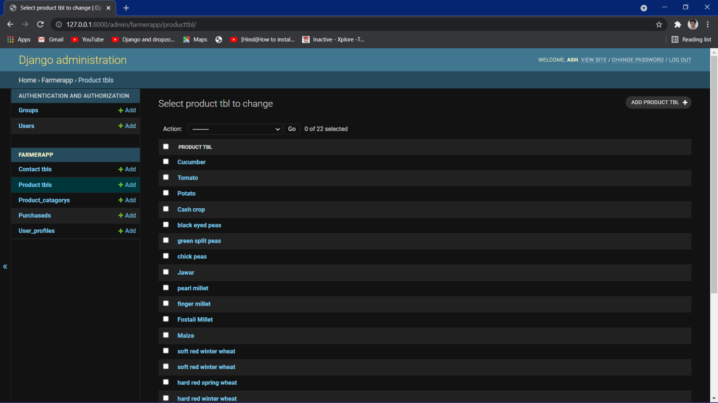

**Add New Product:**

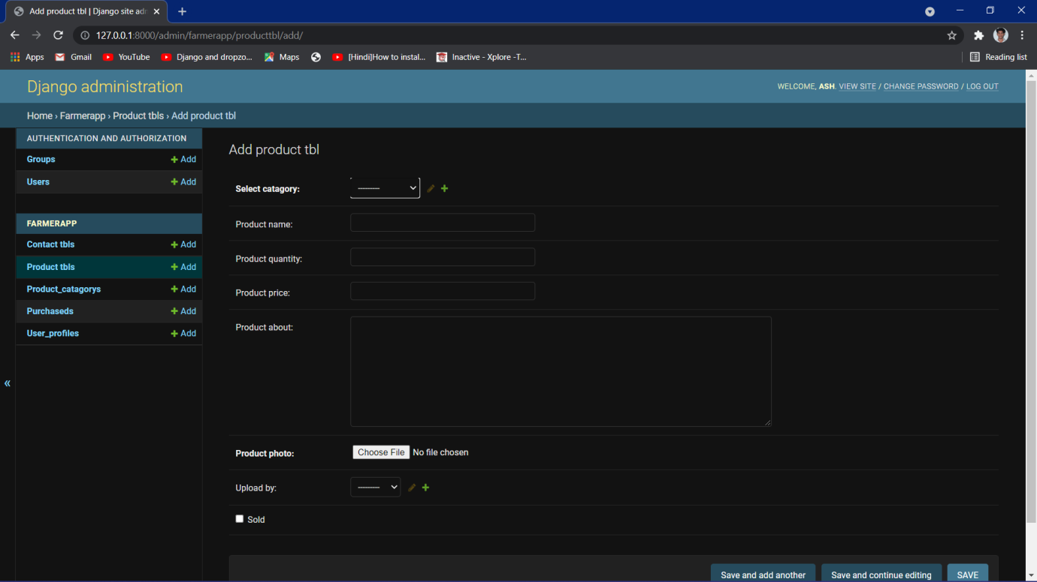

**Farmer app Tables:**



**User app Tables:**

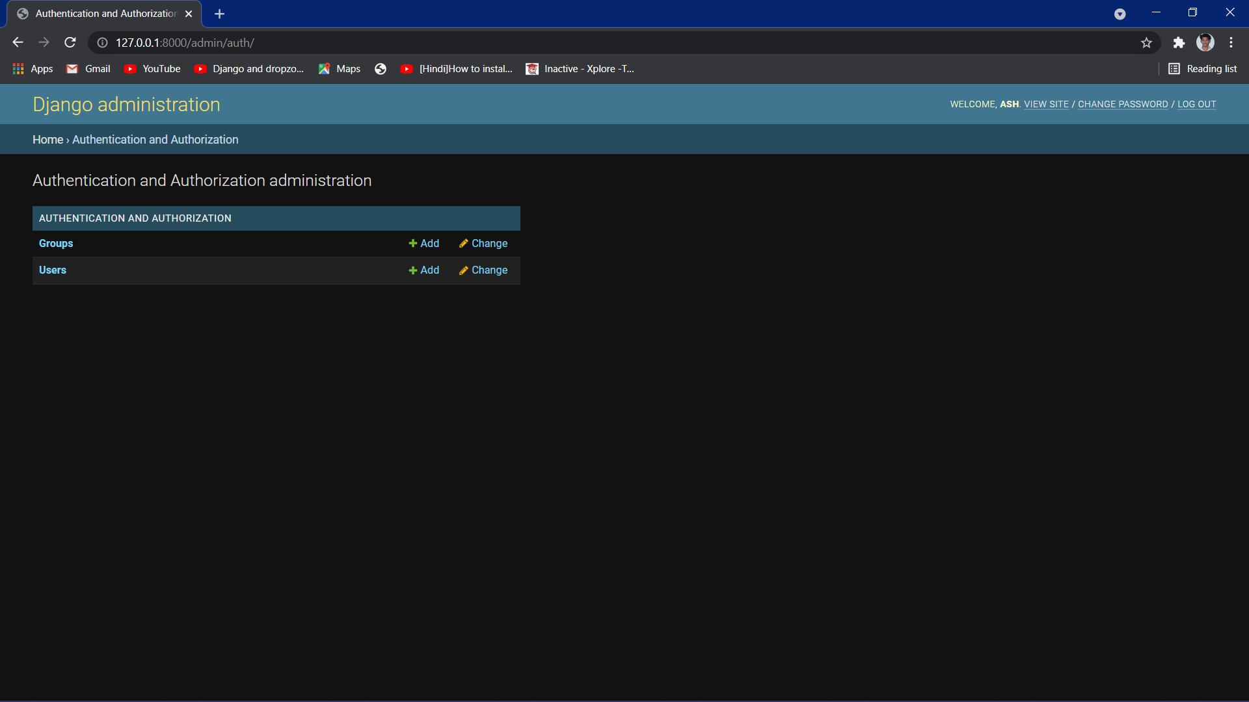

**Update User Profile:**

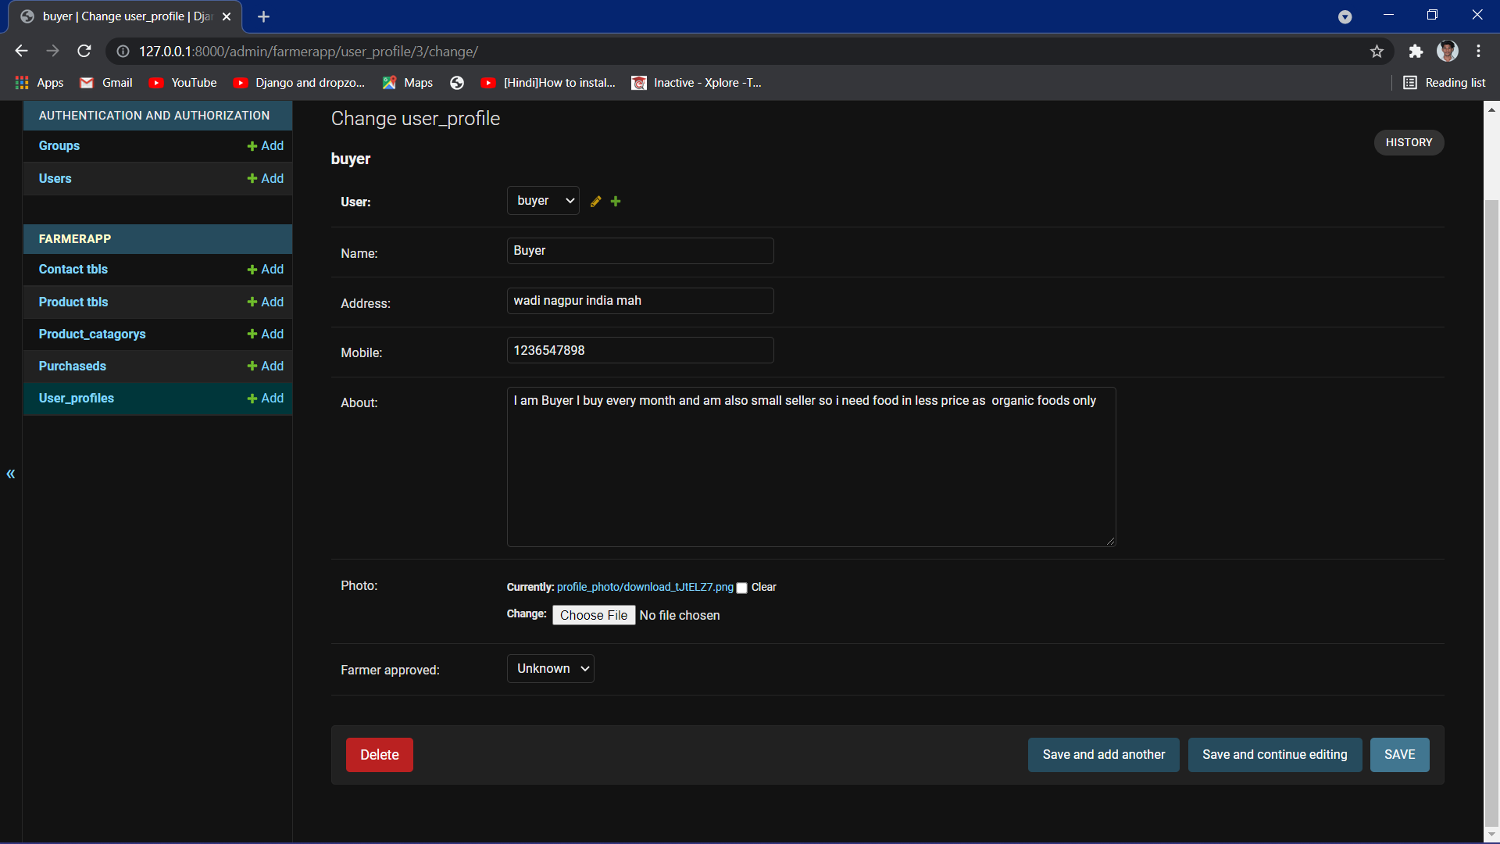

**CONCLUSION AND FUTURE SCOPE**